2022
Partner Agency User Guide
Web-Based Reporting System

Sponsored by:
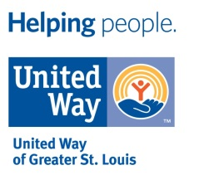

Last Updated: June 7, 2022
United Way of Greater St. Louis

Table of Contents

Introduction.………………………………………………………………………………………………………………………………………………. 3

Brief History of the 100 NC Program…………………………………………………………………………………………………………... 3

100 NC Program Overview.…………...…………………………………………………………………………………………………………… 4

Responsibilities of Partner Agencies.…………………………………………………………………………………………………………… 4

Roles/Responsibilities and Program Changes 5
Roles and Responsibilities, Program and Policy Reminders/Changes 5
Inquiries…………………………………………………………………………………………………………………………………………………………… 7
Proof of Eligibility 7

Case Levels 8
Case Audits 8
Documented Need 9
Managing Case Levels 9

The 100 NC Web Portal 10
Partner Agency Credentials 10
Accessing the Web Portal 11

Entering and Managing Cases 13
Dashboard/Main Menu 13
Enter New Case 13
Mandatory Fields……………………………………………………………………………………………………………………………………….…. 15
Tips for Successful Entry of Cases.……………………………………………………………………………………………………………..…. 15
Important Tips for Successfully Entering Stories…………………………………………………………………………………………... 18
Story Writing Tips ……………………………………………………………………………………………………………………………………….… 18
Family Information………………………………………………………………………………………………………………………………………… 19

Finalizing and Completing Cases 20
Printing Cases...................................................................................................................................................... 20
Final Submission of Cases …................................................................................................................................ 21

100 NC Client Checks and Donations 22
Generating Payment Reports ……………………………….……….…………………………………………………...…………….……………23
Picking Up 100NC Checks to Distribute to Clients ....……….…………………………………………………...…………………………24
Follow-Up Allocations & Designated Donations (Energy Assistance Payments) ….………………………………………....25
Managing 100 NC Adoptions 26

Key Dates for 2022 27

Key Contacts 27
Introduction

This User Guide contains general information and instructions for executing and implementing The 100 Neediest Cases (100NC) program as an approved Partner Agency. The program elements under the oversight of Partner Agencies are referenced in this documentation in order to ensure adherence to programmatic rules, proper submission of client cases into the database, review of cases to ensure for successful submissions and appropriate care for donors and clients that come in contact with Partner Agencies. This User Guide is meant to supplement the mandatory Partner Agency Training and will cover the following:

- Brief History of the Program
- 100 Neediest Cases Program Overview
- Responsibilities of Partner Agencies
- General Rules of Engagement
- Step-By-Step Web Instructions Entering and Managing Cases

Brief History of the 100 NC Program

In 1922 the Social Planning Council (later known as the Health & Welfare Council) organized an effort to collect donations and distribute Christmas baskets to the needy in the City of St. Louis through a program they called the “Christmas Bureau”. The Junior League of St. Louis provided their volunteer efforts, and the program that would later be known as The 100 Neediest Cases was born. The first year about $400 cash and other toys and gifts were distributed with the baskets.

From the late 1930’s, local newspapers publicized the program. Then in 1950, Joseph Pulitzer agreed the Post-Dispatch newspaper would co-sponsor the program. Post-Dispatch artist illustrations opened the door to what would eventually become an annual Art Contest for students throughout metropolitan St. Louis. The Newspaper printed 100 stories which were representative of the problems of the needy in the program. In 1954 the phrase “The 100 Neediest Cases was used as a tag line centered over the story, and the name ‘stuck’.

By the mid-1950’s, donations of stoves, washing machines, and the like, inspired business leaders like Public Movers Association to contribute delivery service for those bulky items. Other community leaders like Famous-Barr gave Christmas parties for disabled children served by the program. In later years they discontinued the parties in favor of ‘Giving Trees’.

In 1975 the Health & Welfare Council merged with the United Fund to form the United Way of Greater St. Louis. Thus, the Post-Dispatch and United Way became co-sponsors of the program and have continued to sponsor this program in the St. Louis Metropolitan Region for more than 40 years.

Last year nearly 60 Social Service Agencies from the St. Louis region (Missouri and Illinois) submitted over 4,000 client cases to the program. The 100 Neediest Cases campaign raises over one million dollars each year in cash donations alone. The 100 Neediest Cases program has been able to distribute every dollar raised to the participating clients in need. This year, 100 Neediest Cases is celebrating 100 years!
100 Neediest Cases Program Overview
CLIENTS
AGENCIES

- Identify eligible cases
- Enter cases and stories into the database
- Serve as liaison between clients and donors
- Register for program via partner agency
- Receive funding
- Receive additional items if “adopted”

- Link donors to
agencies / cases
- Manage allocations
- Manage database
- Assist with program administration
100 Neediest
Cases
- Provide monetary donations
- Adopt cases
- Provide donated gift items

DONORS
VOLUNTEERS

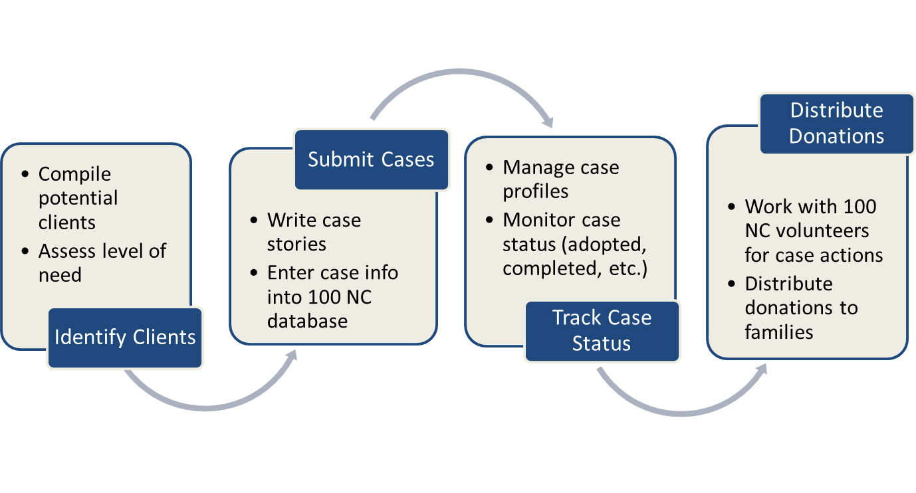
Responsibilities of Partner Agencies

Roles/Responsibilities

ROLES AND RESPONSIBILIITES
We continue to work towards a better understanding of partner agencies’ processes to assess clients’ needs, select cases for submission, work with donors, and manage cases for distribution of donated assistance.

United Way of Greater St. Louis
- Administer the 100 Neediest Cases program (agencies and volunteers) and serve as its fiduciary agent
- Coordinate the distribution of client allocations
- Evaluate and measure performance / outcomes of the 100 Neediest Cases Program
- Manage banking relationships
- Provide Agency Payment reports for client allocation
- Maintain electronic database of client records by agency

100 Neediest Cases Partner Agency:
- Assign a dedicated Program Liaison for execution of the 100 Neediest Cases Program for the agency and attend required annual training
- Implement process for submission of eligible clients into the 100 Neediest Cases program
- Identify, select and submit eligible clients in to 100 Neediest Cases program database
- Ensure up-to-date client records and support the coordination of client allocation distributions
- Work directly with donors interested in adopting agency clients as appropriate
- Update Agency Contact Information by established deadlines
- Track In-Kind Donations
- Adhere to program requirements and communicate promptly with UWGSL staff and/or 100 Neediest Cases volunteers of any potential program disruptions
- Achieve a score of 75% or higher on the annual program audit

Program and Policy Changes/Reminders

NEW PROCEDURES FOR 2022-2023 PROGRAM YEAR:
In Kind Donations Tracking: To capture the entire impact of the 100Neediest Cases program to its families, participating agencies will be given an In-Kind Donation tracking sheet. This tracking sheet must include all Level 1 Case donations made directly to the family with items or goods. An estimate of value can be provided by the donor or the agency and entered in the tracking sheet. If Donor has copy of receipts, they can share that would be great but is not mandatory. One tracking sheet will be given per agency – tabs in the document can be added for each Level 1 case/family.

REMINDERS FOR 2022-2023 PROGRAM YEAR

The following program policy changes were implemented in the 2019-2020 program year to maximize the impact of 100 Neediest Cases assistance for clients/families, focus assistance on more high need client cases, and reduce the overall number of cases to a more manageable balance per program year. By maintaining these standards, we are confident that the 100 Neediest Cases program can provide impactful gifts to the families it serves. Moreover, requiring all clients to qualify at/below 125% of the Federal Poverty Guidelines provides a program-wide standard ensuring we are indeed helping the “Neediest Cases”.

Submission ONLY of Level 1 and/or Level 2 Cases

- Submit ONLY Level 1 and/or Level 2 cases. Adhere to requirements to confirm case eligibility, and demonstrate critical/compelling need in case stories and the potential impact/outcome from receiving assistance
  - Level 1 Cases must meet all program eligibility requirements and case stories must present at least three (3) documented/verified unmet needs
  - Level 2 Cases must meet all program eligibility requirements and case stories must present at least two (2) documented/verified unmet needs

- Utilization of the 100 Neediest Cases Intake Form
  - Eligibility criteria and verification for program participation
  - Implication for continued contact/engagement with client beyond initial intake
  - Agencies that currently use an intake form to register clients for participation in the 100 Neediest Cases program can send a copy of the form for review and approval. This will help to ensure all information required for eligibility is included/incorporated in your form.

Adherence to Program Policies

- Adherence to one check per household address and other residency policies (residency within 16 county service area, no duplicate case entry, complete and accurate client information, etc.)

- Compliance upon request with client case file audits to verify eligibility qualifications were met for submitted 100NC clients (e.g., proof of ID/SS#, income, residency, etc.)

- Adherence to procedures to reduce unwarranted program costs (re-issued checks, bank fees, stop payment fees, etc.) such as returning uncashed checks, payee name and address verification, alternate or emergency phone numbers to contact clients, etc.

Adoptions (Case Specific Donations)

- The 100 Neediest Cases program assists donors to “adopt” cases to provide additional monetary donations, gift items and other assistance to adopted cases. Gift items are collected from donors and distributed directly to adopted client cases. Cash donations designated to adopted cases are collected (by United Way) for disbursement to the clients and/or other parties (landlords, schools, utilities, etc.) based on donors’ intent and use for the funds (rent, food, clothing, utilities, school fees, etc.).

  - Partner agencies must identify responsible agency staff persons and specify its procedures to manage and execute all adoption coordination and donation distribution activities (i.e., gift drop-off arrangements/procedures with donors; and gift/check distribution arrangements/procedures with clients). Since this is a holiday program and transactions might be conducted during holiday hours, please have a contact that is available after hours and on holidays in case issues arise.

INQUIRIES

Client Inquiries:
- Are the responsibility of the Partner Agency and at no time shall the client be referred to UWGSL for inquiries, etc. regarding their case or potential awards.

- NOTE: ALL CLIENT INQUIRIES ARE THE RESPONSIBILITY OF THE AGENCY. DO NOT DIRECT
CLIENTS TO CALL UNITED WAY, 100 NEEDIEST LINE OR 2-1-1 TO DISCUSS THEIR CASE.

Donor Inquiries / Donations:
- Agencies must designate a point of contact for donor inquiries received via email, phone, or in person

- Donor inquiries directed to the agency must be responded to within 24 hours

- In Kind Donations for Level 1 Cases must be tracked by agency on spreadsheet and turned in at the end of the program.

Partner Agency Inquiries:
- Questions should be directed to the following: (Please email questions to all three email address this year)
    - Becky White, Direct Services Program Manager @ 314. 242.1881 / becky.white@stl.unitedway.org

    - Judy Sparks, Program Coordinator – Administrative Assistant @ 314.539.4020 / judy.sparks@stl.unitedway.org

    - Cathy Vaisvil, Community Partnerships Director @ 314.242. 1885 / cathy.vaisvil@stl.unitedway.org

PROOF OF ELIGIBILITY
Partner Agencies are required to verify eligibility of clients submitted to the 100 Neediest Cases Program and ensure that documentation is maintained for client file audits. Eligibility must include the following:

- Proof of Social Security Number
- Proof of Residential Address
- Proof of Income
- Proof Client Meets 125% of the Federal Poverty Guidelines*

2022 FEDERAL POVERTY GUIDELINES (125%)*
# in Family | Annual | Monthly | # in Family | Annual | Monthly
1 | $ 16,988 | $ 1,416 | 4 | $ 34,688 | $ 2,891
2 | $ 22,888 | $ 1,907 | 5 | $ 40,588 | $ 3,382
3 | $ 28,788 | $ 2,399 | 6 | $ 46,488 | $ 3,874
CASE AUDITS
Partner Agencies are required to maintain proof of eligibility to comply upon request with client case file audits to verify eligibility qualifications were met for submitted 100NC clients (e.g., proof of ID/SS#, income, residency, etc.). Client case file audits may be performed randomly between the months of January and June for the 2022 program year. Agencies must score 75% or higher in the program audit to remain full 100 Neediest Cases Partners. Those who score 50% or below will not be able to continue in the program. All partner agencies should anticipate being audited in the next 12 months.

CASE LEVELS
Partner agencies assign a case level and provide information to document level of need for the cases entered into the database. Based on the level assigned to the case, clients are eligible for the following:

Level 1: Case must meet all program eligibility requirements and present at least three (3) documented and verified unmet needs. Level 1 cases are eligible for adoption and are reviewed by allocators to determine amount of monetary donation. Case stories are eligible to be selected for publication in the St. Louis Post-Dispatch. They represent cases with the highest level of need; compelling case stories written for Adopters and Allocators. Level 1 Cases in-kind donations will be tracked on a donation tracking sheet.

Level 2: Case must meet all program eligibility requirements and present at least two (2) documented and verified unmet needs. Level 2 cases are not eligible for adoption, but cases are reviewed by allocators to determine amount of monetary donation. They represent cases that have demonstrated needs but are not critical; compelling case stories written for Allocators.

Case information is required for both levels (client/family names and information, income, expenses, and needs).

DOCUMENTED UNMET NEED:

Examples of documented/verified unmet needs include the following:

- Disconnection notices for utilities
- $500 or more in past due bills owed to a utility company (power, gas or water)
- Medical bills, prescription bills, medical diagnosis, note from Doctor
- 30 + days late on rent; Eviction notice
- Unemployment check, Notification from Employer of status change at work
- Copies of School fees, expenses, or bills
- Order of Protection – Report of domestic violence
- Copy of Police/Fire Report if victim of crime, home fire or disaster
- Car repair bills
- Documents indicating change in Marital Status/Living Situation
- Social Security/Disability letter
- Documents confirming client homelessness/transitional housing

These are only examples, not a complete list. Please contact Program Manager to confirm if a document can be used to verify need and/or program eligibility.

MANAGING CASE LEVELS

Partner agencies are responsible for the coordination and distribution of their clients’ monetary
allocations and gift donations. Partner agencies:

- Take necessary steps to make sure case information is accurate, truthful and documented.
- Take necessary steps to minimize potential program costs such as avoidable re-issued checks, stop payment fees, etc.
- Do maintain contact with clients beyond initial intake; verify and update contact information for distribution of donations
- Do treat Adopters and Donors appropriately and with respect. Be available and respond
to calls/messages.
Do track in kind donations to your cases and submit at the end of the program
- Do not submit more cases than you can handle and manage. This is particularly critical for
Level 1 cases.

Consider your agency and staff capacity to effectively execute the following:

- Respond promptly to inquiries from donors, 100 Neediest Cases volunteers and United Way staff
- Schedule and coordinate arrangements for drop-off and distribution of gifts and donations
- Balance agency Holiday schedules, office hours and availability of staff
- Have space available to securely store and distribute donations.

The 100 Neediest Cases Web Portal

The 100 Neediest Cases web portal is a secure web portal and repository for client and donor information and management. The web portal subscribes to all standards for data security and PCI compliance.

The 100 Neediest Cases database will allow you to:

- Enter all client information.

- Change, add or delete client information as necessary as long as the case is saved and not yet submitted. If changes are needed after the case has been submitted, contact UW staff for editing.

- Print or read client information after the case has been submitted.

- Change and/or delete your agency’s contact information at any time.

The 100 Neediest Cases database will not allow you to:

- Change client information after the deadline for case submissions.

- Change client information on a submitted case unless you request that United Way make the change.

- Enter a social security number that has already been entered during this campaign by your agency or another agency.

PARTNER AGENCY CREDENTIALS

To protect the security of our system, each user will be invited to utilize the database through their email. Agency Admins will receive the initial invite once the 100NC team adds them to the database. Agency Admins will then add their agency users who will receive the invite once entered.

The invite to the system is tied to the email address of the user. This invite cannot be forwarded to another user to enter the database.

Each Partner Agency has a primary and a secondary contact staff person; and can designate the staff member(s) to be assigned the role of “Administrator” for the 100 Neediest Cases Website.

Partner Agencies are required to notify 100 Neediest Cases immediately of any changes to assigned agency staff and their contact information.

ACCESSING THE 100 NEEDIEST CASES WEB PORTAL

When initial invite is received to enter database, please favor the new database in whatever web browser you are using. This will make it easier for you to go back and find it.

To access the 100 Neediest Cases website:

- Connect to the internet and go to the United Way of Greater St. Louis’ corporate website (www.helpingpeople.org).

- Scroll to the bottom of the page, locate and click on the Agency HQ link on the right side of the page.

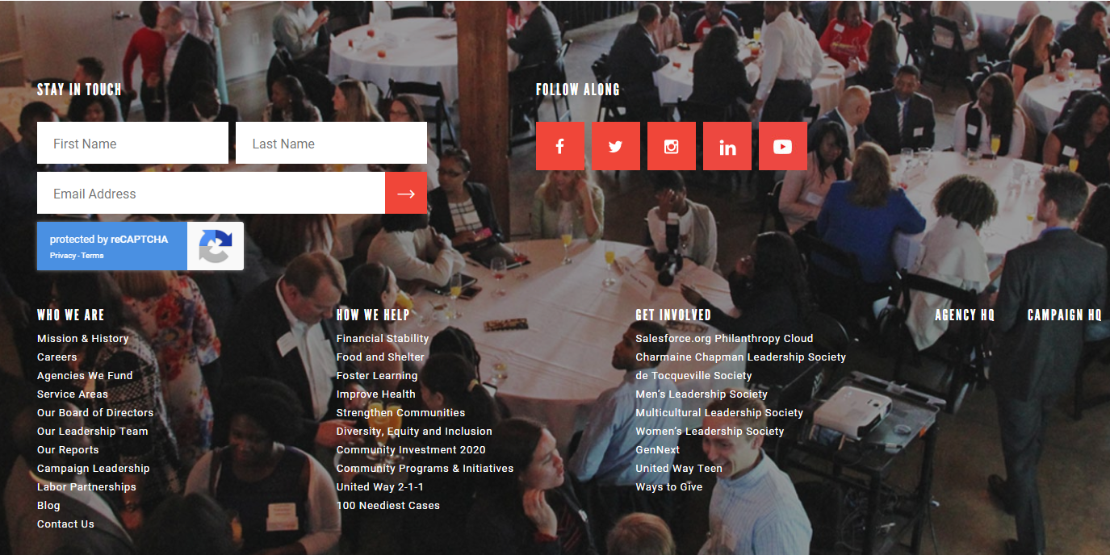

- Scroll down to the Other United Way Programs Locate and click on the 100 Neediest Cases tab. Click on the 100 Neediest Web-based Entry and Reporting link.

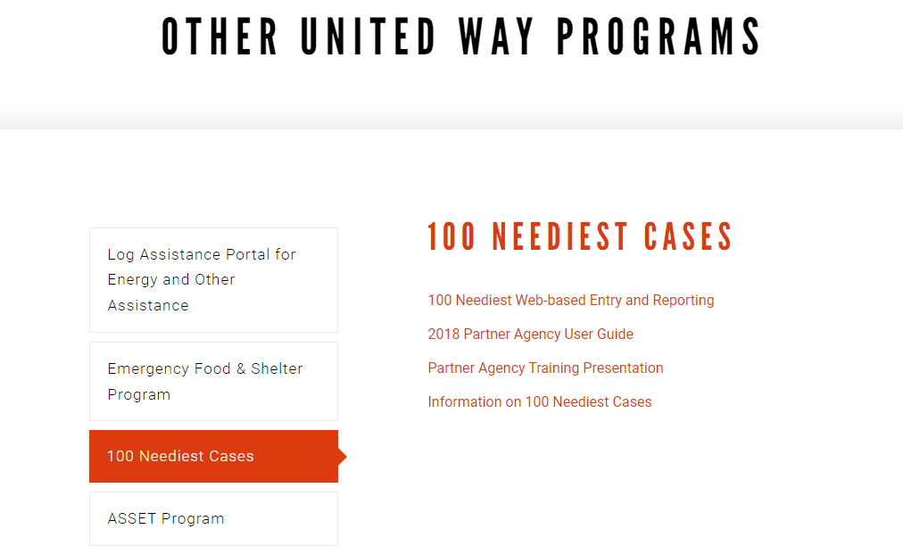

- If you have logged in previously and saved passwords, the system will remember your computer. If you do not remember your log in information you can click on ‘Reset Password’ to reset log in information.

Entering and Managing Cases

DASHBOARD AND MAIN MENU
Upon successful login to the web portal, the first screen to appear is your Case Dashboard. Using this screen, you may manage cases and edit your agency and user profile information.

- Click on “Add New Case” to enter case information and submit case profile once completed.
- Click on “Case Directory” to view all cases submitted by your agency. This screen will include a summary report of all the clients who have been entered by your agency. It will be empty until you begin to enter cases but may be used to edit cases.
- Click on “Advanced Search” to search for cases submitted by your agency,

NOTE: Changes to usernames can only be made by the United Way System Administrator.
(Please contact 100 Neediest program staff to request this change.)
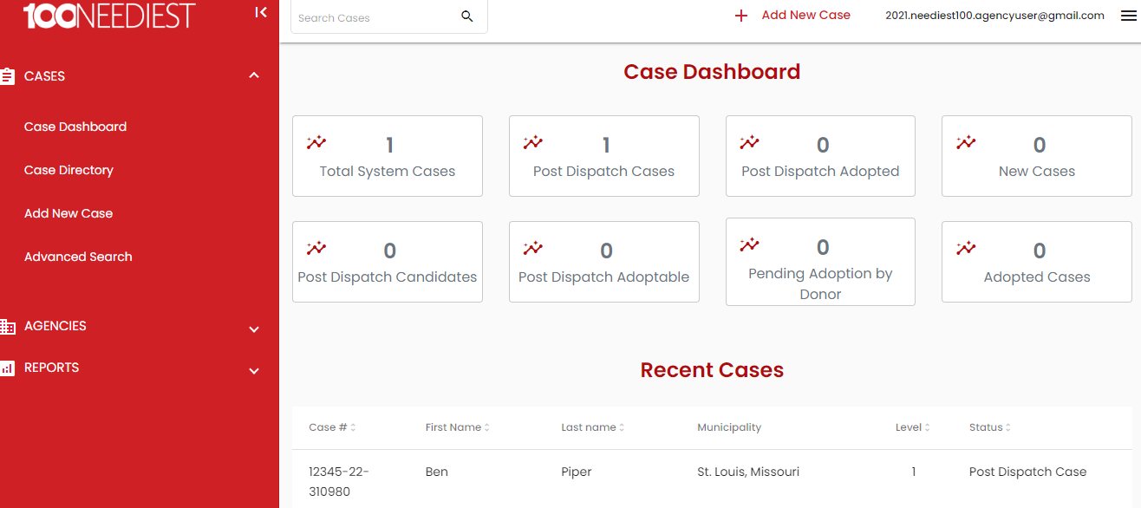

ENTER CASE PROFILE INFORMATION
- To enter a Client Case, click on “Add New Case.” The case profile screen will appear. Enter in the SS Number and click “Search Clients” to see if client is already in the database.
NOTE: A client can only be submitted once. If another agency has already submitted this
client, a dialog box will appear with the agency name, phone number and contact person.
Please refer the client to the agency listed for this years’ 100 Neediest Cases program.

- If client is not already in the database, complete this page in its entirety and click on “Save Case” to save and return or Click “Submit Completed Case” once completed and all information is confirmed.
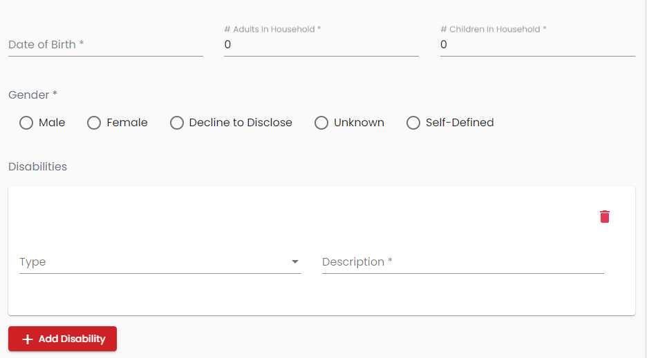
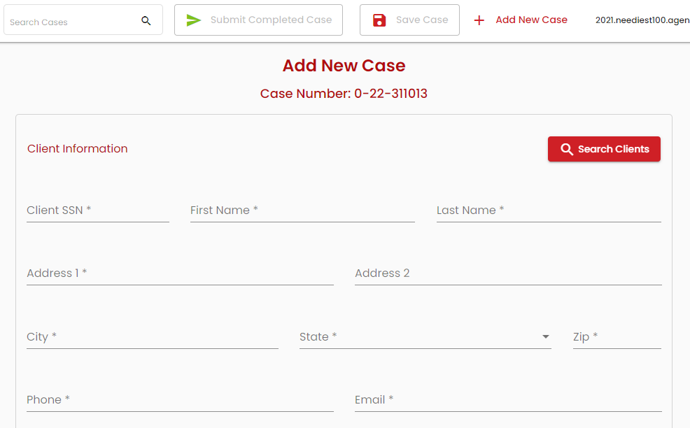
Take Care to Ensure:
- All spellings and data entered are correct
- Demographic info must match the content of the stories
- Monetary disbursements are not payable to children
- Save Partial Case if profile is incomplete
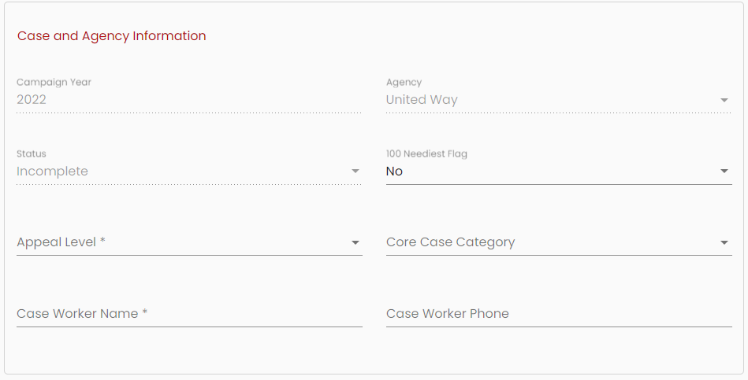

Leave this field as ‘No’

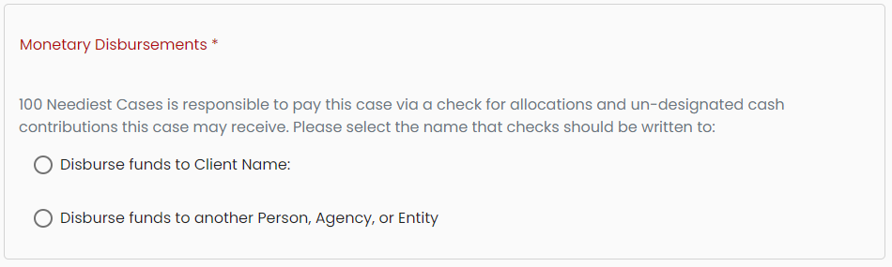

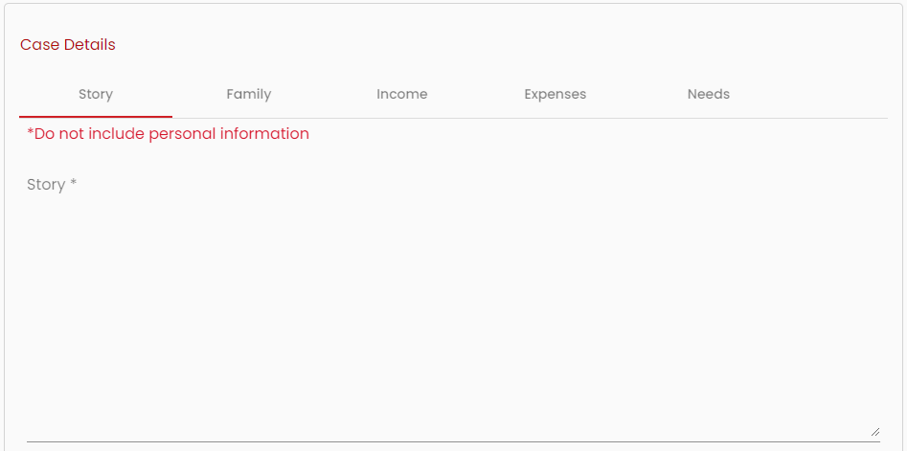

MANDATORY FIELDS
The following fields are mandatory and must contain information in order for a case to be included in our database. Tab between fields and use drop-down menus where available.
- Client Social Security Number
- First Name
- Last Name
- Address (Add Apartment number if applicable)
- City/State/Zip
- Phone
- Email
- Date of Birth
- # of Adults in Home
- # of Children in Home
- Gender
- Appeal Level (Level 1 or Level 2)
- Case Worker
- Monetary Disbursements
- Story
- Family
- Income
- Expenses
- Needs
*The ’Family’, ‘Income’, ‘Expenses’, and ‘Needs’ tabs are located to the right of the ‘Story’ tab. In order to add information to these fields, click on the tab to open that field.

TIPS FOR SUCCESSFUL ENTRY OF CASES

NOTE: The Campaign Year, Status box and the Agency Name are Read-Only fields.

- Confirm the Client’s Social Security number. The database will automatically assign case numbers, campaign year, agency and status.

- Use the tab key or mouse to navigate through the page and enter the appropriate information in each field. Use drop-down menus where available.

- When case is saved to return to – it’s status will be incomplete. Once submitted, case status will be changed to New.

- Tab to ‘Appeal Level’. Use the drop-down box to choose the appropriate Case Level.
  - Level 1 cases must meet all program eligibility requirements and present at least three (3) documented/verified unmet needs. These cases will be sent out for adoptions.
  - Level 2 cases must meet all program eligibility requirements and present at least two (2) documented/verified unmet needs. These cases will not be sent out for adoptions.

- If there is a disability in the household, click on the ‘Add Disability’ tab, enter any other important information, i.e. the client is bedridden, etc.

- In the Family tab, List the client and any other family members. List all those age 17 and under as children. Include extended family members, relatives, or friends who may be living in the household. Do not put last names in the family tab – it is a required field so just put in last initial or NA.

- Be certain to complete all elements of the Story Box (Story, Family, Income, Expenses and Need). Click on each heading and fill in the appropriate information. Use the drop-down boxes where indicated. Click on the ‘Add’ button to add new items.

- Make sure you save your information often (using “Save Case”) to ensure you preserve your case information. Once all information is entered, “Submit Completed Case.”
NOTE: Only one case per household address is allowed; thus, all in the household
should be referenced. Please be certain that the story detail matches the number,
of men women and children listed in the client information section.

NOTE: When entering text in the story boxes, it is required that you only use first names.
Failure to do so may impact your cases level category.

After all information has been entered, select:
- ‘Save Case’ at the top of the page.

- Confirm all information is correct and make corrections as needed. Then click the ‘Submit Completed Case’ button at the top of the page. (If this button is grayed out, there is information missing somewhere on the application – review for completeness. Once all fields are entered, this button will be available)

- When you do this, a case face sheet will appear that can be printed or saved to .pdf

- When you see this message, the process is complete.

IMPORTANT TIPS FOR SUCCESSFULLY ENTERING STORIES
General Rules
- Agencies are responsible for the program’s integrity when entering stories.
- Clients may not enter their own stories in the 100 NC database.
- Partner agency staff/employees and their families are not eligible for this program.
- The Case Story must never contain the last name of any client to protect their identity from the public. Use the client’s first name (Ben) or first name and initial or title (Ben A., Ben Jr.) to describe family members. Failure to follow this requirement may prevent the case from adoption eligibility.

- The Case Story is read by donors to decide whether they will adopt the case, and by volunteers to determine what monetary amount will be allocated to the client. A succinct, clearly written, grammatically correct and compelling story that will inspire donors and volunteers should be submitted for Level 1 and Level 2 cases. Remember when writing case stories, “Longer is not necessarily better.”

Cases with Appeal Level 1 (only) will be sent out to the public for adoption. Cases with Appeal Level 2 will not be eligible for adoption.

Every case is not a Level 1. If the story does not support the level, it will be amended appropriately. Also, it is very important that you do not enter more Level 1 cases than
your agency can handle.

NOTE: All cases must have a compelling case story, have demonstrated need for
assistance, and information must be entered in all mandatory fields:

STORY WRITING TIPS
Entering information on the ‘Expenses’ and ‘Needs’ tabs greatly increases your client’s opportunity to be adopted. Easy shopping makes happy donors!

Many donors are looking to help clients with particular needs or special circumstances, so include details in the story, i.e. veteran, working, going to school, fire, catastrophic illness, domestic violence, youth in foster care, immigrant/refugee, etc.

Do Not:
- Use the ‘Enter’ key on your keyboard to move from place to place. Use the Tab key.
- Enter client last names anywhere in the database except in the Last Name field on the Client Entry. Never include last names in a Story and do not include on Family tab. (Just put last initial or NA)

Do:
- Be descriptive and use adjectives to appropriately and legitimately describe your case:
  - The Post-Dispatch sorts their stories by categories like Disabled, Elderly, Veteran, Single Father, Single Mother, Foster Child, or Grandparent raising Grandchildren. They may also sort families affected by events such as fire, auto accidents, crime victims, health conditions, diseases or medical mishaps.
  - Many donors like to help struggling clients who work or go to school.
  - Some want to help families who have recently resettled in the United States from another country.
  - It is helpful to think about how you would describe the client in terms of categories like these, and to write that information in the Case Story. Use more than one adjective to describe the client. For example: “Mary is an elderly, bedridden woman recently diagnosed with cancer.”

- Write something personal about the client:
  - Describe something about the client’s demeanor, interests, fears or concerns. This will help the reader empathize with the client and want to become personally involved in helping him/her. For example: “Mary has asthma and uses oxygen. She stays active by volunteering at her grandchildren’s daycare.” // “Ms. S and her 3 young boys ages 5, 7, and 10 were able to get an apartment after being homeless due to domestic violence. She works full time but struggles to pay utility bills.”

- Be deliberate and specific when entering needs and wants:
  - Tell specifically what the client needs and/or wants. For example: “Mary needs Depend-like Undergarments, and she wants a soft down pillow for her head.” // “Ms. S is seeking help with electric utility payments, and clothing and holiday gifts for her sons.”
  - The more specific you can be, the easier it is for a donor to adopt.
  - Be sure to list these specific items and number of items needed in the ‘Needs’ tab under ‘Need/Quantity/Description (Specific sizes for each member is entered in the ‘Family’ tab)
  - Do not list brand names or luxury items under any circumstances.

- Check for spelling, flow and grammatical errors:
  - Review for errors
  - Use (but don’t solely rely on) your spell check button before you save the story for submission
  - Donors rarely adopt hard-to-read stories.

FAMILY INFORMATION
- The client’s family information, including other family members, their relationship to client, age, gender, clothing and shoe sizes, are used by donors to purchase gifts for clients and their families.

- List anyone 17 years or younger as a child. Seventeen years or younger can be the Client also, but a check cannot be payable to them.

- Include as family the extended family members, relatives or friends who may be living at the
household address.

NOTE: All cases must have the Family Information page fully completed.
Do not put last names on the Family page. (Just put last initial or NA in that field)
Finalizing and Completing Cases

Before submitting a case, ensure the following:

- Does the story have a beginning, middle and end?
- Is the story succinct but complete? Remember that longer is not necessarily better.
- Does the story invoke empathy for the client?
- Is the story legible, readable and easy to follow? Remember donors must be able to understand the story or it won’t get adopted.
- Have you checked for correct spelling and accuracy of information entered?
- Does the detail of the story match the number of family members in the family tab?
- Confirm that the number listed in household matches number in case story.
- Have you included last names in the story details? No last names please.
- Have you included specific suggestions for gift donations?
- Be sure descriptions of gift suggestions are generic --- do not mention luxury items or brand names.
- Everything (story, family, income, expenses and needs) must be entered and saved successfully – Status: NEW
- If guidelines are not followed – program administration reserves the right to change case story level.

A Client’s complete information doesn’t have to be entered in one sitting. Some information may be entered at one time and then some at another. Select ‘Save Case’ near the top of the page to save work as needed.

Do not submit a case until all data is entered on all screens. Once a case is submitted and confirmed, it should be Read or Print Only. BE SURE AND SELECT “SUBMIT COMPLETED CASE” when ready to submit. (If this button is grayed out, there is information missing somewhere on the application – review for completeness. Once all fields are entered, this button will be available)

If you find that you need to change any demographic information after a case has been submitted, call The 100 Neediest Cases office. After changes have been made, you can log onto the web to print a revised copy, if desired.

PRINTING CASES
- Click on the “Case Directory” link on the Main Menu / Dashboard Page
- To print a single case, Click on the “Case Directory” link on the Main Menu/ Dashboard Page. Select and open the case on the Case Directory. Choose the .pdf option on the ‘Available PDFs’ drop down. Then click ‘Download PDF’. Once downloaded, case can be printed directly from the PDF.
- To print all or multiple cases at once, click on the ‘Advanced Search’ link on the Main Menu / Dashboard Page. Enter search criteria or click ‘Search’ to pull all cases. Enter check marks next to name of cases you want to print. Choose the .pdf option on the ‘Available PDFs’ drop down. Then click ‘Download PDF’. Once downloaded, multiple cases can be printed directly from PDF.

FINAL SUBMISSION OF CASES
- Agencies must submit all cases by the due date. This is non-negotiable.
- After the due date, the web portal will only allow an agency to read or print information.
- Any changes required after submission must be made by the 100 Neediest Cases program office.

100 NC Client Checks and Donations

GENERATING PAYMENT REPORTS

Look to receive instructions to download and review the checks and payment information made available to your agency through the 100 Neediest Cases website. Only the Primary 100 Neediest Cases Contact or Agency Administrator for your agency will be able to view your agency report. From the Case Dashboard, go to Reports

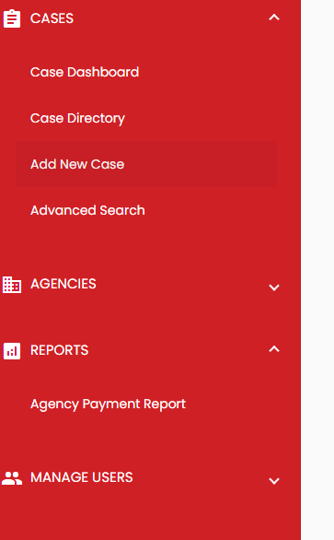

Click “Agency Payment Reports” and the following page will appear.

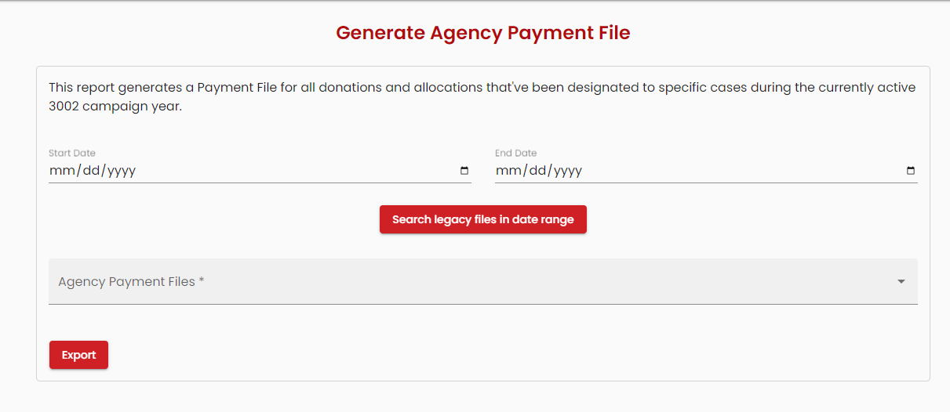

Enter Start Date and End Date for Report – click Search legacy files in data range. To Export, choose Agency Payment File Report from drop down and then Export.

PICKING UP 100 NEEDIEST CASES CHECKS TO DISTRIBUTE TO CLIENTS

Partner Agencies are responsible for all communication with clients regarding the distribution of 100 Neediest Cases checks and donated gift items. Do not direct clients to call United Way, 100 Neediest or 2-1-1 for information regarding their case, adoption status, donation check, etc.

Partner Agencies will receive a notice with instructions on how to access their payment report via the 100 Neediest Cases website. Agencies will be able to download the list of cases/clients receiving checks and other donations for each scheduled payment allocation (see timeline and key dates).

Checks are cut for each case receiving a monetary donation. These checks will be sorted by agency and arranged in alphabetical order by client last name. Each Partner Agency must inform United Way in advance the name of the agency representative(s) who will pick up all 100 Neediest Cases checks for their agency. This agency representative will need to sign to receive the checks. Checks not picked up will be mailed to the Partner Agency for distribution, unless alternate pickup arrangements are made.

Some agencies may have checks held from distribution pending review of cases for the following reasons.

- More than one check per household address policy
- Duplicate entry of client case (within the same agency or multiple agencies)
- Invalid or lack of accurate client information
- Client address outside the United Way service area

REMEMBER:
- Agencies are required to work directly with their clients to distribute monetary donations and other gift items. Do not direct clients to contact United Way or 100 Neediest Cases volunteers regarding their case.

- Agencies serve as the liaison between the client and the donor. Information is confidential.

- Agencies are required to honor the donor’s intent for the monetary donations and gifts given to the cases adopted

What If:

- Name on check is incorrect | - Client is not responding to calls/messages
- Not able to locate client | - Client is now deceased
- Client moved | - Check was lost, destroyed, etc.

Please contact United Way staff to arrange to reissue checks (if appropriate), return checks, void checks, etc.

FOLLOW-UP ALLOCATIONS AND DESIGNATED DONATIONS

Follow-up allocations for the 100 Neediest Cases program checks will be processed and mailed to agencies. These second/third allocations are primarily comprised of dollars that have been donated to a specific client from a donor. The vast majority of those are unrestricted for the client to spend, and checks to the clients are prepared for these designated contributions. A few are restricted. Agencies receive these funds in a check included for them. Agencies are responsible to help assure that donor restrictions are honored.

Managing 100 Neediest Cases Adoptions

Donors who have chosen to adopt a case are instructed to:

- Purchase at least one gift for each person in the adopted family.
- Wrap and tag each gift with the first name and age of the recipient.
- Bag or box all gifts and list the case number on the bag/box. If they adopt more than one case, they are instructed to use separate bags/boxes for each case, and not to include personal checks and/or cash in client boxes.
- Send an email message to the Agency Contact listed on the client case form if they need additional information regarding the case selected to adopt.
- Confirm with the Agency Contact the best day and time to deliver gifts for the adopted family.

Partner agencies are required to ensure prompt response to donor requests and inquiries.

- Make sure you communicate promptly with UWGSL staff and/or 100 NC volunteers of any potential program disruptions and holiday closing schedules.

- Make sure your agency’s contact person’s name and information is accurate in 100 NC system.

- Make every effort to respond to donors within 24 hours to plan to drop off gifts/donations.

- Provide the name of designated contact person(s) and alternate person(s)
- Communicate your agency’s holiday schedule (dates closed, office hours, etc.); and provide optional dates and times to arrive to drop off donated items/gifts
- Provide clear directions to your drop off site and share any special instructions for drop-off location and entry, parking, drop-off procedures, delivery for multiple sites, etc.
- Confirm final arrangements (e.g., date, time, exact location and contact name) for drop-off of all donated gift items.

REMEMBER:
- Agencies are required to work directly with the donors that have adopted their agency’s cases
- Agencies are required to honor the donor’s intent for their gift (e.g. do not take donations from one case/client to give to different case/client)
- Agencies are responsible for purchasing any Gift Cards for clients per donor specification/designation
- Level One donations this year must be tracked on the In Kind Donation Tracker at each agency. Donors can be asked to estimate the cost of the donated items.

PLEASE TREAT DONORS WITH RESPECT AND EXPRESS YOUR APPRECIATION FOR THEIR GENEROUS DONATIONS TO THE 100 NEEDIEST CASES PROGRAM

Key Partner Agency Dates for 2022

ALL DATES SUBJECT TO CHANGE - You will be notified accordingly.
These dates are for internal and programmatic use only

- July 2022 100 NC Partner Agency Training
- July 18, 2022 Web portal Opens – Begin Entering Case Stories
- September 9, 2022 Web portal Closes – No Longer Able to Enter Case Stories
- Sep 12 - Oct 17, 2022 Screening of Cases for St. Louis Post Dispatch
- October 17, 2022 Selection of Top 100 NC Stories for Post-Dispatch
- Mid November 2022 Publication of 100 NC Stories in Post-Dispatch Begins
- Mid December 2022 100 NC Checks - Pick-Up (1st Cut for Allocations)
- January 2023(2nd /3rd week) 100 NC Checks - Mailed (2nd Cut for Designations)
- March 2023 100 NC Checks - Mailed (3rd Cut for Late Designations)

Key Contacts

Contact information is for internal and programmatic use only.

100 Neediest Cases Program Office (Opens September 12, 2022) @ 314.421.6060

100 Neediest Cases Program Administration

- Becky White, Direct Services Program Manager @ 314. 242.1881 / becky.white@stl.unitedway.org

    - Judy Sparks, Program Coordinator – Administrative Coordinator @ 314.539.4020 / judy.sparks@stl.unitedway.org

    - Cathy Vaisvil, Community Partnerships Director @ 314.242. 1885 / cathy.vaisvil@stl.unitedway.org

